Abstract

The idea for this project was borne on coming to realisation that not many UX evaluation tools nowadays are available to use as open source and without charging users any registration costs.

Aims

**The aim of the project is to build an UX Evaluation tool.**

Introduction

(**Elaborate a bit more?? What will the product do? How will it be used? Who will use it?)** Using this tool web developer will be able to upload screens of their prototypes on the tool for their mobile application prototype or desktop web application prototype. Two surveys have been created, participants will participate in the survey, fill out the survey and the survey results will be feeded back to the user.

The advantages of the tool will be:

* It can provide some relatively quick and inexpensive response in the form of results to the designer.
* Feedback can be obtained early in the design so designers can fix problems, make changes to design and then implement and built the actual product.
* This tool can be used with other UX evaluation methodologies to get more comprehensive results.
* Users can be remotely located and still be able to do the survey as the survey is online. This will also enable to increase the number of participants and get more and more feedback. Further this also means that a formal laboratory setting is not required for doing the tool based survey, participants can do the survey from home or anywhere they like.
* Since the feedback is coming straight from the users this can be reliable to use rather than involving a third person to interpret results.

Literature Review

User experience can be defined as satisfactory or unsatisfactory state of user's mind throughout the interaction with the system. In other words, one can boil this down as to how comfortable user feels while interacting with the product. User experience can further be distinguished based on user’s age, level of expertise, gender and ethnic backgrounds. (Wang et al., 2008)

“UX is an important factor which covers all integrative and synergistic aspects of designing good user interface experience.” (Rajesh Kumar, Omar and  Mahmud, 2013)

This also means products/ services created not only meets customer expectations but also are enjoyable and creates a positive experience for user. A good UX is quite essential to retain the user’s engagement with the product. (Rajesh Kumar, Omar and  Mahmud, 2013)

In order for the product to be successful, the product should be able to deliver a delightful experience to the user. Developing a product/ application is not just about implementation and testing, but to also make sure the product exhibits resonance with the user’s expectations and needs. UX is a common topic these days, however there are not many tools available to test a product in its development stage. (Kaisa, Roto and Hassenzahl, 2008)

Evaluation of UX cannot simply be carried out using user logs or stopwatches or by supervising completion of task assigned to user. This may include recording where the user clicked the most, how long it took to navigate and get to a specified page or to complete a task of booking something online. However these factors alone are not reliable when carrying out UX evaluation. One needs to interact with the user, find out user's expectation, what feature they would like to have in the application. The user’s expectations and their feelings are much more reliable UX evaluation factors than lab based UX experiments/ supervised task completions. Additionally, the context in which the product is used also leaves a great impact on the user experience. (Obrist, Roto and Kaisa, 2009)

IEEE- Current tends in usability evaluation methods, freddy paz, jose….

According to ….Usability is considered as a vital success factor for any product, and there are various usability evaluation methods that have been developed. Many papers and literature resources are available that explain about various kinds of usability evaluation methods available. however, there is a varied discussion seen amongst all the authors and their research about which usability method is best to use. Several papers suggest some usability evaluation methods that are widely used and that yield great results,but these results are mostly restricted to specific type of software applications of a specific category. They do not provide a solution for types of software products available.

A study carried out by (<http://ieeexplore.ieee.org/stamp/stamp.jsp?arnumber=7023887>) determines that usability tests, questionnaires, heuristic evaluations are the most used techniques. Another finding that was shown by this study is that questionnaires and surveys have been widely used by developers to measure usability from user’s point of view. The methods of using surveys is quite popular and developers are putting more and more effort into formation of  best questionnaires/ surveys that could help assess the usability of their product. Many researchers suggest different approaches, and also users should select appropriate method based on their type of product as each method has its own set of pros and cons.

A study carried by (<http://www.ijmijournal.com/article/S1386-5056(08)00180-9/abstract>) compared three usability evaluation methods in lab settings. The methods were Heuristic evaluation, Cognitive walkthrough and think-aloud method. According to the authors Heuristic evaluation is a fairly effective method, however, it requires evaluators to be expert and highly skilled to be able to construct reliable outcomes. Cognitive walkthrough is a well-thought-out approach than heuristic evaluation but it requires high level of detail of task and participant background description. The last method they studied was think-aloud method which is a relatively direct method than the other two to gain insights into problems that users face or misconceptions that they face while using the system, however,  once the test is done it requires an extensive  level of data analysis. All the three methods have their own benefits and drawbacks, neither of the methods fits best to be used as stand-alone method. Although a right approach would be to use these methods as combined techniques so that they compliment each other and provide a better yield rather than using one method singly.

A similar comparison was carried out by(<http://www.sciencedirect.com/science/article/pii/S1532046410000687>). In this comparison, four usability evaluation methods were compared during the development of outpatient clinical documentation software. The methods were clinical email reponse, online surveys, interviews and observations. Results from this comparison advised that no one methods helps in identifying most of the usability issues and that each approach may be suitable for different stages of the software design and sheds light on distinct usability aspects. According to the authors surveys and email responses are best done we have a working prototype, whereas observations and interviews as best

done whilst we are in the early design stage of the cycle. Relying on one single method may not give complete results, and this is why one should consider combining two or more methods at various stages of the design cycle of the prototype.

Therefore, it is believed by the author that involving users and their personal experiences with the product and taking their feedback about the product would prove to be a far more effective way to measure and improve UX.

## **Need for an UX Evaluation Tool**

The invent and the growth of internet has transformed the lives of most. The growing use of internet has led to an increase of web based mobile or desktop services that intertwine with day to day lives of hundreds of people. On everyday basis people use these web apps, mobile apps like planners, messaging apps, email services etc.

However, websites and other forms of web services have become increasingly complicated as new technologies have emerged in the industry. That’s why it has also become more and more challenging to satisfy all the user needs, deliver an engaging and satisfying user experience.

In order to provide a great user experience, the businesses or individuals need to make sure that the design process is going in the right direction. *Precaution is better than cure.* This phrase can be very well linked to a scenario where a product is build and released for use, and fails to meet user needs/ requirements, as a result the product design needs alteration which might cost the business or the individual quite a lot of money to change existing features and implementing new ones. On the other hand, if the user needs were acquired and analysed in early stage when the product was the form of initial prototype, mock up or wireframes, it would have been far easier to implement the contextual and design changes then, rather than leaving it until late.

Before a single line of code has been written.

## **User Experience and Usability the same thing?**

It is quite easy to get confused about the difference between usability and user experience. They seem to be the same things but in reality they are two distinct aspects. User experience in a major part of usability. User experience is often abbreviated as UX and sometimes people tend to confuse this term with usability. Although use experience and usability are two different things, there is a connection that existing between these two.

* Usability: The ISO Definition of usability is concerned with “effectiveness, efficiency and satisfaction with which specified users achieve specified goals in particular environments” (ISO 9241-11). Usability defines how effective the product is helping users accomplish their task. Users have certain goals when they use a product or a website for instance, usability is related to the ease with which users were able to reach their goals effectively. Usability means being able to accomplish a certain task or in other words how effectively was the certain task/ goal accomplished.
* User Experience: The ISO Definition of use experience is concerned with “all aspects of the user’s experience when interacting with the product, service or facility” (ISO 9241-10). User experience is about the feelings, emotions and experiences the users had when they used to product. The product might have left them feeling very happy, angry, confused or frustrated. It is the way users perceive their interaction with the product. For example, “Is the user feeling delighted after user the website?”

Usability Evaluation Methods

There are two types of evaluations based on evaluation objective:

1. **Formative** **Evaluation**: Formative usability testing play the role of supporting tool during decision making in the early stages of the design process. This design technique focuses on the efficiency of the prototype. This type of evaluation also has a lot to offer because it determines the usability problems and helps eliminate them through redesign of the prototype. It is best to apply this type of evaluation in the most early stages of design process to gain valuable insights of usability problems that users might face while using the website, mobile application or any other services. Formative usability test works well with paper prototypes which are not functional at that moment. This may contain pen and paper low fidelity prototypes, wireframes. These initial prototypes contain the contextual flow of the product, and can potentially aid in decision making around general layout and the navigation.  A combination of expert-based and user-based inspection methods has evolved to facilitate the formative evaluation process. Usability evaluation methods are used for formative evaluation in the design stage.
2. **Summative** **Evaluation**: This evaluation comes after the formative evaluation.  Summative Evaluation is done after the product is developed, this is usually done to analyse the design of the product and measure its efficiency in comparison to other alternatives. http://www.idemployee.id.tue.nl/m.m.bekker/hartson.pdf

The main focus of using usability evaluation tools is to aid in selecting the best design and to make sure that the product development is going in the right direction. Additionally, to also gather the User's expectations or feedback that could be implemented in the further product design.  Few of the existing usability evaluation methods include Lab studies, Field studies, Surveys, Expert Evaluation.

These methods are briefly explained below:

* **Lab Studies**:  Lab studies have proven to be highly efficient in early testing of prototypes.  In this test the participants are provided with user interface design. Participants are then asked to use the user interface and think-aloud as they are using it. This slows down the process and gives the analyst/ developer to comprehend the participant’s actions, monitor them closely. Analysts can also spot the problems related to usability and solve them sooner.  Some of the lab tests also use the approach of real-time tracking of user experience. Such experiments require careful setup and creation of lab-environment applicable for particular study.
* **Field Study**:  This evaluation method is where UX evaluation takes place in a real life scenario and can be carried out by conducting some interviews and observing the users in real life contexts.
* **Surveys**:  Surveys are like an instant feedback tool. They allow developers to highly benefit on using them, by providing results in a relatively short time span. Surveys are effective in most of the scenarios as they feed the users opinions back to the developers at a lightning speed.  Surveys are easy to conduct as they do not require a lab set up. Online surveys are quiet effective in measuring UX evaluation as the group of participants can be bigger. A survey being online means that more and more people can make use of them rather than having to physically be present to participate in lab study evaluation methods.  Another survey method is the use of Emocards, these are very easy to use and as mentioned above, survey method requires very little or no set up. Participants select one of the eight faces each representing a different emotion. Using this method would prove to be beneficial also because the results are outputted in numerical form and hence makes it easy to analyse results.

[**http://www.lltoolbox.eu/methods-and-tools/evaluate-prototypes/emocards**](http://www.lltoolbox.eu/methods-and-tools/evaluate-prototypes/emocards)

* **Card Sorting:** Card sorting is a participatory design technique used to explore how participants group items into categories and relate concepts to one another. This method is used to determine how users will classify information on website/ app. The variants of card sorting are:

1. **Open Card Sort**: In this type of card sorting participants are given some cards and there is no right are wrong answer, all the answer are quite open. They can create their own names for categories. Developers can understand how users perceive different things and what mental names have they got each category. This method is a generative method and thus helping developers to identify patterns in how participants categorise information and this finally helps them to organise various contents on their website or application.
2. **Closed Card Sort**: Closed sorting is evaluative. In a closed sort participants are provided with predefined group names. Participants are then asked to place cards into one of these pre-defined groups. This helps developed identify the degree to which participants agree on which  cards belong under which group. it is used to judge if a provided set of category names provides an effective method to organise a given collection.
3. **Reverse Card Sort**: This type of testing is also called tree testing, here the current structure of categories and subcategories is tested. Even this type of sorting is evaluative because it determines whether the hierarchy of categories is effective in users finding the right information.Participants are given tasks and are asked to complete them navigating through a set of card. Each card contains the name of subcategories and the participant has the find the most relevant category related to the task given to them starting from the top level categories. Participants have to finish the task without any aid of navigational tools, visual designs. This is what makes this method evaluative. (http://www.usabilityfirst.com/usability-methods/card-sorting/)

* **Cognitive Walkthrough**: Cognitive walkthrough is another type of usability inspection method, this method targets are identifying how easy it is for new users to interact with the system to complete the desired tasks? The methods focuses on assessing learnability for infrequent users. Cognitive walkthrough is a task specific method and begins with task analysis. This task is carried out by evaluators who ask usability questions from user’s perspective. Advantage of such method is that it is quick and inexpensive to apply, do not need real users to assess usability, on the other hand, however, not involving real users means having to rely on evaluators. This means that the value of data yield is limited to the skills and expertise of the evaluators. (<http://www.usabilitybok.org/cognitive-walkthrough>)
* **Pluralistic Usability Walkthrough**: This is the usability evaluation method that brings together the group of users and the system designers to evaluate the usability of the system. This walkthrough is conducted by identifying primary tasks, and then going through the tasks  one by one to identify usability issues as going along. The main focus of this evaluation is to produce a maximally usable human computer interaction. Advantage of this type of evaluation is that it provides immediate response and opens up scope for discussions of problems to possible remedies for the problems while the users are still present there.(<http://www.usabilitybok.org/pluralistic-walkthrough>)
* **Heuristic Evaluation**: Heuristic Evaluation Method is also carried out by evaluators who help in identifying the problems with the User Interface design. A documentation or a software product is compared to a list of usability principles (the heuristics). Usually two or three analysts evaluate the system, this type of evaluation can be performed anytime during the product development.
* **Heuristic Walkthrough**: Heuristic Walkthrough is a combination of the features of Pluralistic Usability Walkthrough, Heuristic Evaluation and Cognitive Walkthrough.
* **Focus Group**: In this method, experts speak to a group of target users. Focus groups are used to identify some current issues with the website/ product and the level of contentment. The person who is speaking to the targeted users should be experienced. This is necessary to gain the trust of the target users, so a good communication can be established. Through a focus group one can directly learn about user’s expectations, attitude, reaction to concepts. During a focus groups target users will talk about their experiences or expectations and one can listen to them and draw conclusions from that. The advantage of Focus Groups is that a lot of information can be obtained, and many problems about the website can be exposed. However, the expert talking to the target users should be a skilled professional.(<http://ieeexplore.ieee.org/document/4730538/citations>)
* **Thinking Aloud Test:** This method involves direct observations of users. The users are asked to think aloud as they are performing a given task. Simply put, verbalizing their thoughts as they move along the interface trying to accomplish task. This method is easy to implement as it only needs 3 things:

1. Recruit participants as test users
2. Give them a task
3. Listen to them as they think aloud

This method has many benefits, it helps to identify the misconceptions that the users have in their mind, serves this as recommendations and and enables the developer to fix the changes in the website. This is where one can identify what users think wrong about the UI and why some parts of the UI are easy for them. The downside of using such method is that it does not provide a detailed statistics, for a detailed result one might need to carry out a huge, expensive study. On the other hand the benefits are:

1. Inexpensive: There is hardly any set-up cost for this test.
2. Flexible: This test can be applied at any stage of development lifecycle, from low fidelity paper prototypes to fully working products. This method is suitable for any type of user interface. The method can be applied to a wide range of products as in the end we are relying on the user’s thinking.(<https://www.nngroup.com/articles/thinking-aloud-the-1-usability-tool/>)

* **Interviews**: Interviews are a great way to extract information from users for understanding of usability. They are cheap as there is hardly any setup cost required and can be easily conducted by anyone who can ask questions, interact with potential users and record the answers.

UX Evaluation Tools

As a UX/UI designer it might seem that it with years passing by it is getting more and more challenging to keep users happy and satisfied. The involvement of websites and mobile applications in people’s daily life is quite huge. As a result of reliance on technologies and mobile and web apps, the users demand even more with new interface they come across. Following are some of the existing UX evaluation Tools that could be used to improve the design workflow and keep up with the user’s expectations. (http://uxmastery.com/resources/tools/)

|  |  |
| --- | --- |
| **Design Prototyping**   * UxPin * Balsamiq Mockups | **Evaluating Information Architecture**   * Optimal Sort * Tree Jack * Loop11 |
| **Heatmap**   * CrazyEgg * ChalkMark * ClickHeat | **Survey**   * SurveyMonkey * UsabilityTools |
|  |  |
|  |  |

**Design Prototyping**

* **UxPin**: UxPin is an instant wire framing and prototyping tool. This design platform also lets user create rapid mock-ups. It has libraries for Bootstrap, iOS, Android which get updated regularly. The platform enables to transform static mock-ups into interactive prototypes all completed with interaction animations and other interactive features. It also lets one share these designs with colleagues and clients and also get feedback from them even if they do not have an account.
* **Balsamiq Mockups:** This is another rapid wire framing tool which reproduces the experience of working on a whiteboard but instead using a computer here. Its main focus is in helping to generate new ideas and creating simple mock-ups. This tool is more powerful at the ideation stage and is designed for collaboration. It uses the drag-and-drop UI library, so for instance, if someone types in “button”, it will recognise the word and drop and “button” in the workspace.

**Evaluating Information Architecture**

* **Optimal Sort**: Optimal sort is another research tool which is used by UX developers, this tool is created by OptimalWorkshop. The tool uses the technique of “Card Sorting” to help developers understand how other people would organise a bunch of content items. Card sorting technique is used to find out how other people think the content should be laid out and get user insights which are required to make information architecture decisions.
* **TreeJack**: TreeJack is an Information Architecture Validation Software which is also created by Optimal Workshop. This technique is used to evaluate the findability of topics on website once all the navigation aids have been removed i.e., information is laid out in a text format without the aid of any visual design.
* **Loop11:** Loop11 is another good remote usability testing tool, in this it allows unmoderated remote usability tests involving actual users. In this test a researcher provides a task to user and then tracks the user interaction. The data obtained is presented in a report format which shows task completion rate, failed pages and a detailed path analysis for users. The advantage was seen that this is easy to use, no code is required, however, during carrying out research for this project, it was seen that on Loop11 developers are charged a fee of $350 which is relatively high if test is only need for like 5-10 group of users.

**Heat Mapping, mouse-tracking and Synthetic Eye tracking**

* **CrazyEgg:** Crazy Egg is another quite popular click tracking usability evaluation tool. It lets the web developer see exactly what people are doing on the website. The data which is displayed includes heat maps of popular places on the webpage and data based on clicks. CrazyEgg is fairly easy to set up in this user just has to put the Javascript code on the page they wish the do tracking on. CrazyEgg provides excellent data report and analysis of click tracking. However, this is only limited on one session, user cannot have data for multiple sessions or for multiple hours.
* **ChalkMark:** ChalkMark is another product made available by Optimal Workshop. In Chalkmark an image is shared with users to get feedback from them and also know about where they would click to perform a task. Image can be easily uploaded on their tool and then ChalkMark generates survey URL which can be shared with participants. Then participants are given a task and they have to click on the image where they think the task would be. ChalkMark does real time tracking and generates heat map which researchers can download in pdf format. This seems to be very similar to card sorting, however, researchers do not have way to ask participants that why they clicked on particular area of the image.
* **ClickHeat:** Click Heat is a great tool, firstly, because it is free to use, it is open source tool. Secondly, because it tracks real users who are trying to accomplish real task in realistic scenarios. It then provides a very interesting display of results through heat maps. However, this tool has rather specific software, server specifications which need to be properly understood.

**Surveys**

* **SurveyMonkey:** SurveyMonkey is not just meant to be used for UX evaluation, but this product can be used to create surveys for any type of product or business. This tool enables to create and send surveys with ease. SurveyMonkey enables to use real users and hence gives a chance to make real decisions with real data. The surveys can make use of more than 15 question types, and surveys can be sent out using mobile, web or social media. There are various plans on their website which user can select depending upon their usage. The plans are called Basic- Free for up to 10 questions per surveys, Select, Gold, Platinum- these three are all paid annual plans.
* **Usability Tools:**

**Why low fidelity prototypes will be used?**

**Wireframes- what do wireframes consider?? Why only contextual design decisions and not visual design decisions**

**How would this product be better than others??**

**Pros and cons of having to use lo-fi.**

**Complementing with other products.**

Previous work

**Previous work on ux survey tools, existing tools.**

Methodology

# Methodology used for UX tool

The Waterfall Methodology was used in the project which is based on the idea of design, build, test, implement. This methodology is used for the building of UX evaluation tool.  This method is also called as linear-sequential life cycle model. It is simple for use and understanding and best suited for small projects. General overview of waterfall method:

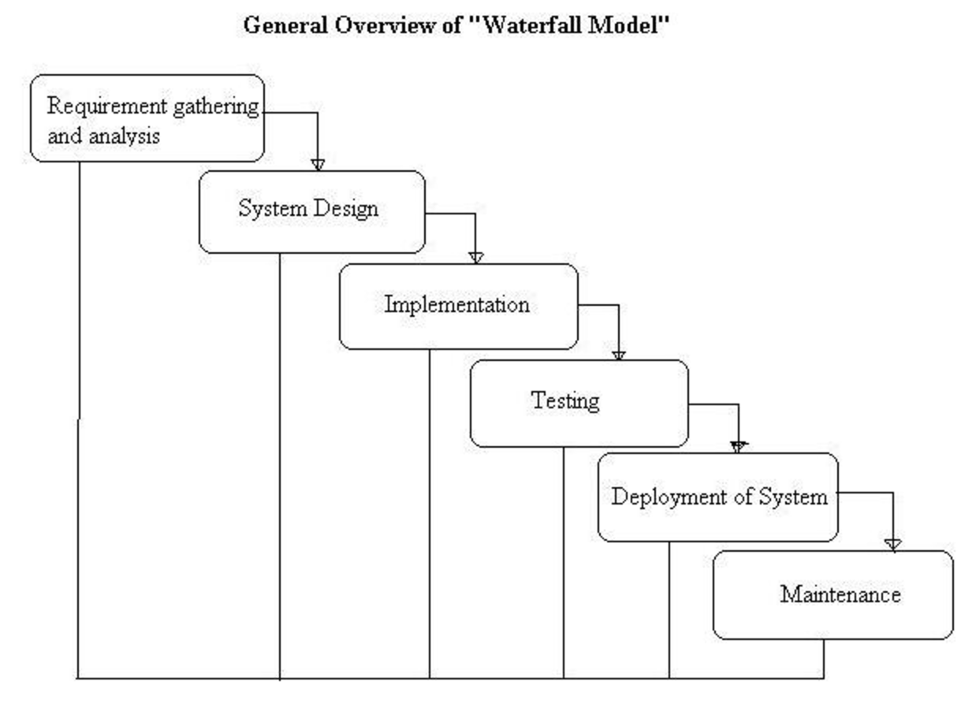

<http://istqbexamcertification.com/wp-content/uploads/2012/01/Waterfall-model.jpg>

Waterfall methodology was chosen because:

* This model is simple and easy to understand and use.
* It is easy to manage due to the rigidity of the model – each phase has specific deliverables and a review process.
* In this model phases are processed and completed one at a time. Phases do not overlap.
* Waterfall model works well for smaller projects where requirements are very well understood.

<http://istqbexamcertification.com/what-is-waterfall-model-advantages-disadvantages-and-when-to-use-it/>

# Methodology used for Data Collection

http://mypeer.org.au/monitoring-evaluation/data-collection-methods/

The two methods to collect data are qualitative and quantitative data collection methodologies. Qualitative Research Methodology is used for exploratory research to gain understanding of reasons, opinions. It provides insight into a problem or helps to develop ideas for research. This method virtually includes any information that can be relevant and which is not numerical in nature for example In-Depth Interviews, Direct Observation and Written Documents. Quantitative, on the other hand, as the name suggests is a formal, systematic standardised approach of collecting data.  Quantitative research involves generating numerical data, or data that can be devised into some sort of statistics. For the data collection part of this project Quantitative methodology is used. There are various forms of surveys- online surveys, paper surveys, mobile surveys, online polls and systematic observations. In this project UI developers upload the screenshot of their prototype onto the UX evaluation tool and create surveys, surveys are then taken by the participants and they fill out surveys forms, the forms asks questions about the various Usability aspect of the prototype. The results obtained from the survey are then analysed by the system and shown to the UI developer. For instance “30% of the users could spot the navigational items easily.”

http://www.snapsurveys.com/blog/4-main-benefits-survey-research/

Survey methodology is used because it allows to analyse the results of large population, number of respondents can be increased while keeping the survey the same, this method is inexpensive and quiet extensive. it helped cover a broad user group, thus promising accurate model to collect aimed results in which to draw conclusions and make important decisions which are to be used by the developer to enhance usability. Anonymity of survey lets the participants give more accurate and honest answers, that’s why this method proves to be beneficial and hence is implemented in this project.

By harnessing the powers of the existing technologies two surveys have been created on the UX tool. One for the evaluation of mobile screen prototypes and one for desktop web app prototypes. The surveys built for evaluation method comprise of various forms of questions: closed questions, multiple choice questions etc. Users can create the surveys for their prototype. The nature of surveys built can be quite dynamic depending on what aspects of usability the developer wants to assess. Surveys on the ux evaluation tool have covered various types of questions as each type of question provides limitless range of varied data with reliable results. Also the fact that the survey is available online proves to be quite beneficial because this will reduce the time taken in collecting data and interpreting the results manually. There will be no problem of losing or damaging the paper surveys. Sometimes in hand written surveys responses/ answers can be difficult to interpret. Having an online survey also means that one doesn’t have to worry about the placing a survey in a location where it can be monitored. This also means eliminating the need of consumable materials required for survey monitoring.

# Methodology to Evaluate Surveys

What sort of reports will you be presenting?

Design

## **Use case diagram**

The users of the UX evaluation tool are the UI Developers and survey participants.

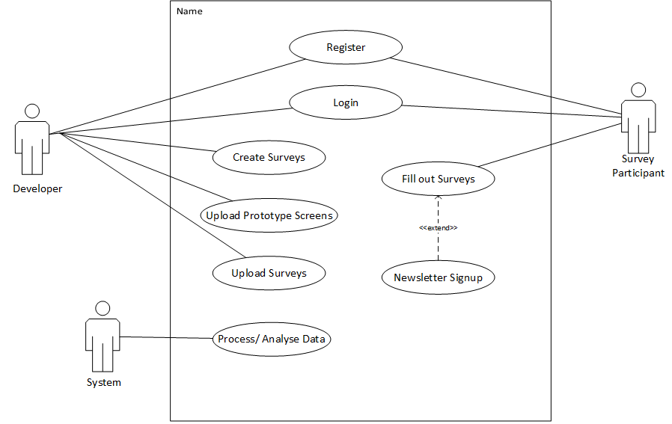

## **Initial prototype (Hand drawn Sketches)**

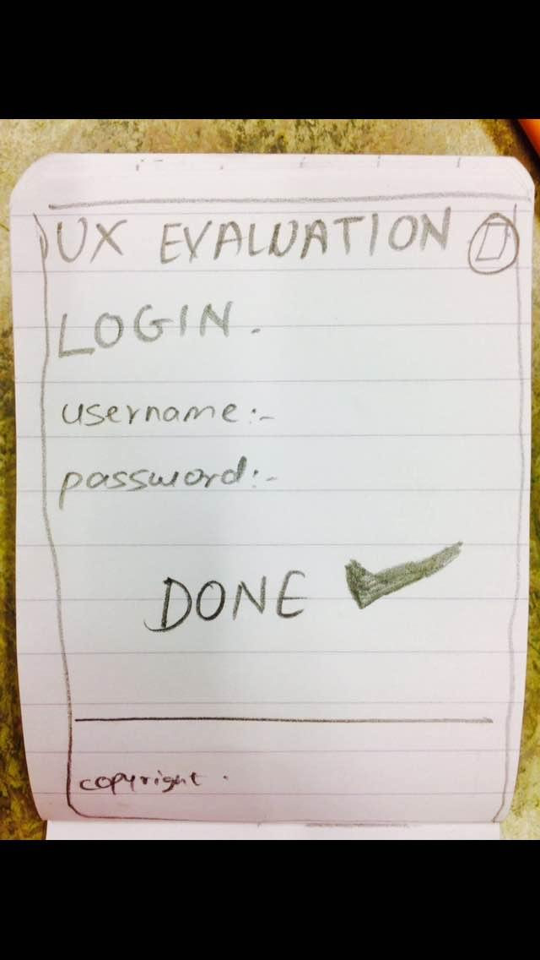

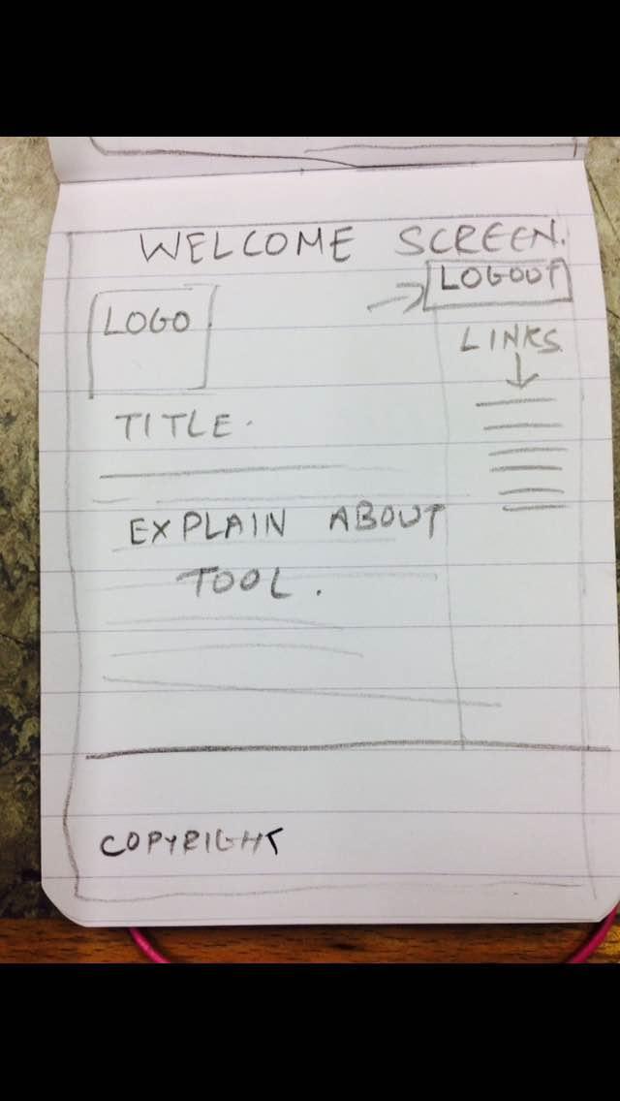

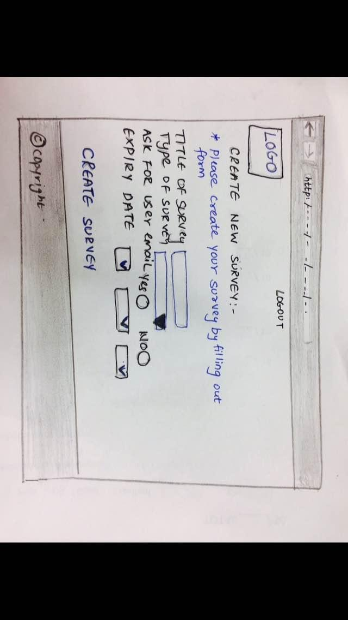

**ER Diagram of the Database**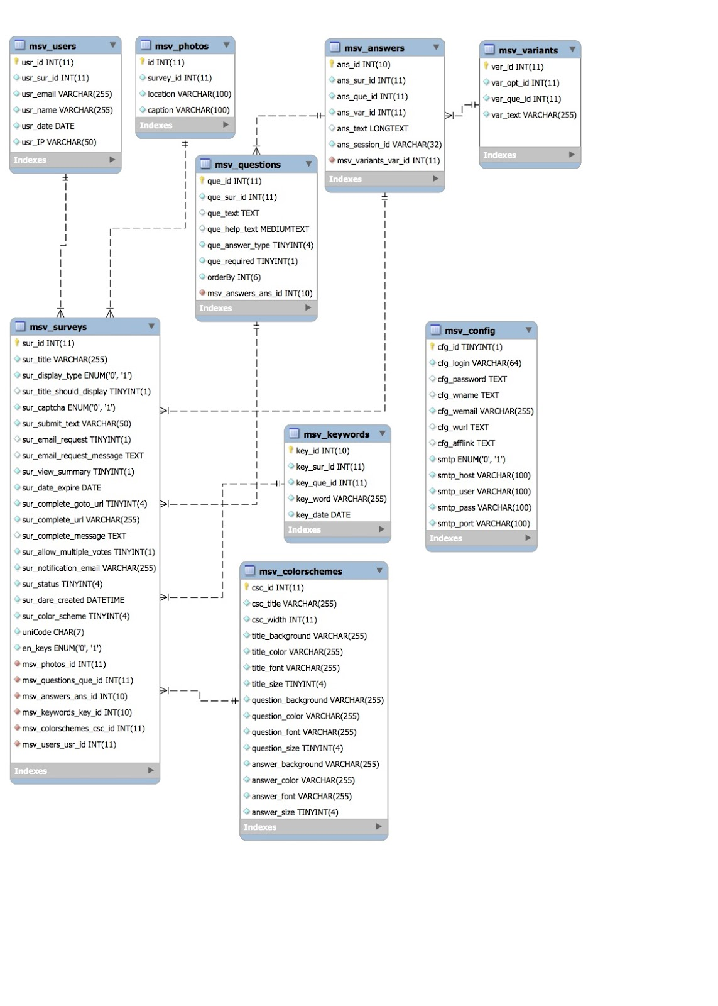

Implementation

The languages used for development of the UX evaluation were Apache Web server, mySql for back end database management, php web app development language. WAMP server was used to host the website on the local host.

**# INSTALLATION:**

- Installation instructions basically one needs Apache server, PHP and mysql.

- After server installation (link WAMP, XAMPP) put 'uxevaluation' folder from source code folder to the webroot path.

- Using phpmyadmin one can create a database name 'uxevaluation' and import the database script from 'uxevaluation05_11_16.sql.zip' from 'mysql_db' folder

-Now that database is imported we are almost done but if you have created a separate database user instead of root then you need to open the following file from the webroot folder,

uxevaluation\inc\connect.php

 and update the newly user credentials below

define('DB_USER', 'root');

define('DB_PASS', '');

- Now you can access the site using following credentials

[http://localhost/uxevaluation/admin/index.php](http://localhost/admin/index.php)

Credentials:

uid: admin

pwd: admin

- That’s all about the app installation and setup.

**# Requirement/Manual/help:**

@ Server Requirements:

-A server running 'PHP v5.0' or higher. Earlier versions are not supported.

-A 'MySQL' database to hold the software tables. MySQL5 recommended, but MySQL4 should be fine.

-GD Graphic Library support for single page display captcha display.

@ Version/Testing:

- Browser Testing: IE7, IE8 & IE9, Opera, Firefox, Google Chrome, Safari (PC)

- Coding Standards: XHTML Transitional, CSS2/CSS3

- Development Environment: Xampp running PHP 5.3.1, Apache/2.2.12, MySQL 5.1.41

- Operating Systems: Windows 7 (Development), Linux Centos5 (Production)

- Error Reporting Level for Development: E_ALL | E_DEPRECATED

- PHP Debugging & Profiling: Xdebug / WinCacheGrind

 Final Implementation

  Actual screenshot of the website built

Evaluation

What sort of surveys were there?

How many users used the surveys?

What was the response?

How did you evaluate that?

Future Work